Gladys Marie (Zurcher) Nussbaum
February 20, 1931 – November 6, 2024

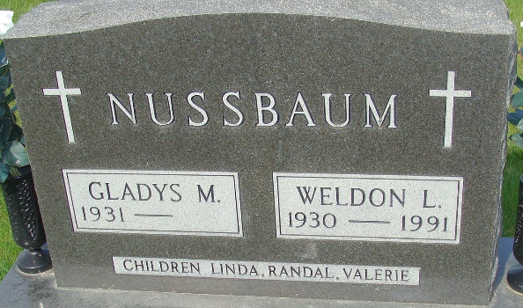
Photo by Alicia Kneuss

Gladys Marie Nussbaum passed away early Wednesday morning, November 6th, 2024, at Swiss Village Retirement Center in Berne, Indiana, with family at her bedside. She was born on February 20, 1931, to William and Eva (Stauffer) Zurcher. She graduated from Monroe High School and married Weldon Nussbaum on December 17, 1949.
She was a member of Cross Community Church of Berne and had been employed as a bookkeeper for Zurcher Tire of Monroe, Secretary to the Superintendent for Adams Central Schools, and an assistant to the Treasurer of Adams County.
Her family was always the most important thing to her, and she will be greatly missed by her son, Randy (Susan) Nussbaum of Hope, IN, daughters: Linda (Mic) Hodson of Berne and Valerie Liechty of Ohio City, OH, grandchildren: Jeromy (Kim) Alberson, Branden (Tracy) Alberson, and Danielle Alberson, of Berne, Kyle (Kara) Alberson of Wooster, OH; Dr. Nick (Kris) Nussbaum of rural Decatur, Tiffany Schortgen of Huntertown, IN, Zac (Stephanie) Nussbaum of Hanover, IN, Eric Liechty of Ohio City, OH, Eric (Nichole) Weireter of Duram, NC, Brent (Krista) Weireter of Richmond, IN, Ryan (Mikayla Smith) Weireter of Crestview, FL, and Jason Weireter, of Fort Myers, FL; 27 great-grandchildren and 7 great-great-grandchildren, with another due next May; sister-in-law Vera Zurcher of Elkhart, IN, and many nieces and nephews. She was preceded in death by her parents; her husband, Weldon Nussbaum, one sister, Naomi Macy, 5 brothers: Art, Paul, Dale, Vernon and Joshua Zurcher, and two grandsons; Ben Nussbaum and Daniel Liechty.
A celebration of her life will be held at 3:30 p.m. on Sunday, November 17th. Friends and family will be received from 1 p.m. until the time of the service, in the Swiss Village Auditorium, with Chaplain Mike Wertenberger officiating.
Memorials may be made to Swiss Village.

The Berne Witness, Adams County, Indiana
November 7, 2024

