Fred Nussbaum
November 14, 1896 – September 1981
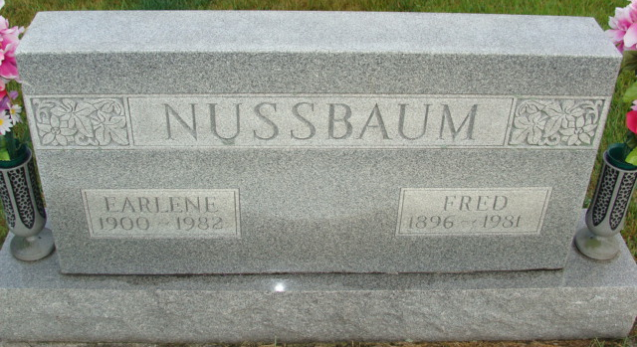
Photo by Alicia Kneuss
Indiana, U.S., Death Certificates, 1899-2017

Name Fred Nussbaum
Gender Male
Race White
Marital Status Married
Age 84
Birth Date 14 Nov 1896
Birth Place Indiana
Death Date 13 Sep 1981
Death Place Decatur, Adams, Indiana, USA
Death Registration Date 1981
Father John Nussbaum
Mother Ellen Baumgartner
Spouse Earlene Habegger Nussbaum, informant
Burial MRE 9-16-1981

