Eloise L. (Smith) Nussbaum
1932 -

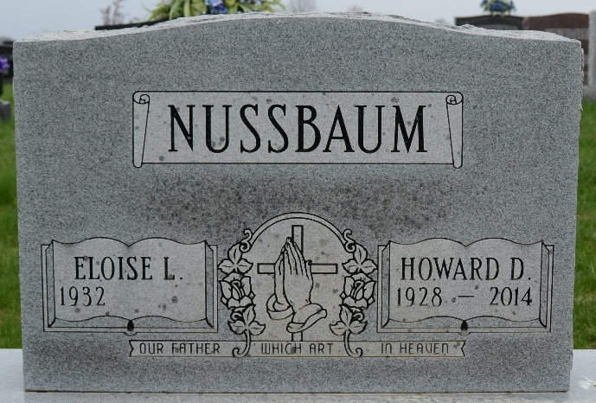
Photo by Deb Curry

