David W. Nussbaum
February 20, 1931 – November 23, 2023

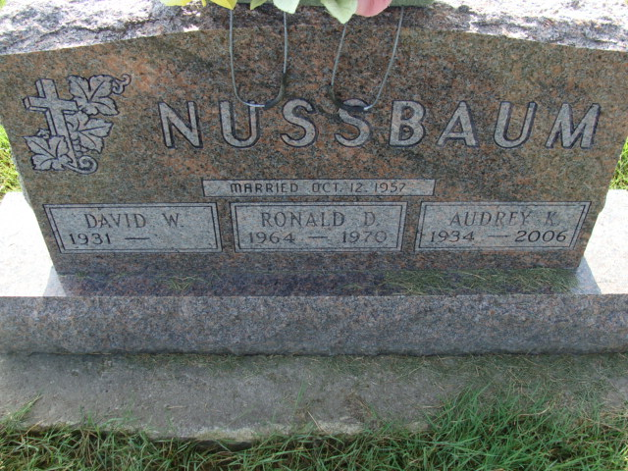
Photo by Alicia Kneuss

David W. Nussbaum, 92, of Berne, Indiana passed away Thursday, November 23, 2023, at Swiss Village in Berne, Indiana. He was born on February 20, 1931, in Berne, Indiana to the late Clifton L. and Louise E. (Lehman) Nussbaum. Dave was united in marriage to Audrey K. Whitehurst on October 12, 1957, and she preceded him in death on October 23, 2006. On January 10, 2009, Dave was united in marriage to Carolee (Loudin) Roop and she preceded him in death on October 3, 2022.
Dave served the church standing behind First Mennonite cameras for decades and began broadcasting radio services long before that. The worship commission wanted the entire congregation to hear Dave’s story of service to honor him and give thanks to God for the talent and dedication of Dave Nussbaum. Dave’s love for broad-casting began early and took him to Chicago, where he studied Television Service. Dave followed up his two-year program in Chicago with a six-week course in New York where he spent much of his free time in a live studio audience. “My Hit Parade,” Dave’s favorite show to watch live, involved singers who took turns performing songs on stage. He even sat in on some live radio programs while in New York. Upon returning home, Dave settled into a job as a cameraman at WKJG TV Channel 33 in Fort Wayne. He worked the early shift, beginning broadcasting at 6:00 a.m. with a live pastor offering a devotion each morning. Live local news followed and then the NBC network morning shows aired. After the Today Show and the Morning Show, Dave would film more live news before more network shows, like soap operas, filled the afternoons. Dave really enjoyed his job and the people he worked with. He specifically remembers John Seymour, a newscaster who also hosted a live morning show for kids called “Engineer John.” Dave fondly remembers blowing through a half-inch pipe to make a whistling sound like a train for the show. Seymour called that “The Berne Train” because he knew Dave was from Berne and Berne still had a running train at the time. All of Dave’s co-workers knew he served at First Mennonite in broadcasting, and Dave chuckled to remember the nickname they gave him, the “Rubber-Tired Amish.” He especially enjoyed working with Hilliard Gates, calling him “a great announ- cer.” Most days, Dave would work from the station. On occasion, they would venture to the Coliseum, and one time they came to Berne—First Mennonite Church to be exact. They produced a Christmas morning program and Dave recorded the bell choir at church for the occasion. He also is the one responsible for arranging for the Berne High School Choir to sing for the station’s “Carols for Christmas.” They had a program lined up and one school canceled, so they asked Dave if he knew of a choir they could record. He took them to Berne where they recorded audio of the choir, and then brought the students to the station to film them lip-syncing to their own recording. The recording of the local high school choir was a long-standing tradition. Dave’s work in recording at church began when he saw the equipment being used at his workplace. The church had begun sending church services through telephone lines to Swiss Village, but in 1952 Dave began looking at the equipment he was using at work and asking, “Why can’t we do this at church?” And so the legacy began. The church purchased a remote transmitter so local people could pick up the church services as long as they had a scanner. This service continues even today. They transmitted radio services exclusively for 32 years until 1984 when Reverend Bauman encouraged the church to purchase a camera and move to television. Dave remembers, “...everything was moving to television then.” Reverend Bauman’s leadership toward this advancement brought television broadcasting to First Mennonite. Surprisingly, the addition of a television broadcast was a bit of a controversy. Many residents of Swiss Village at the time thought the service unnecessary and were against the advancement. The church used one camera for a long time, then purchased a second for the chapel. After a while, two cameras were used in the sanctuary, pulling the one from the chapel each service. Eventually, a third camera was purchased so two could remain in the sanctuary and one in the chapel. Of course, cameras have been upgraded throughout the years, with the latest upgrade of high-definition cameras. Mrs. Les Lehman wrote the “Songs of Praise” radio program that Dave produced. At the start, Dave would record Reverend Bauman’s part two weeks in advance, spending many hours at the church in preparation for airing. He eventually convinced the leadership to give him his own key to the church so he could come and go as needed. Out of appreciation for his talent and dedication, they gladly gave him a key to the church!
He is survived by a daughter, Nancy (Danny) Mock of Berne, Indiana; daughter, Michelle (Chris) Sealscott of Berne, Indiana; step-son, Jeff (Sandy) Roop of Geneva, Indiana; step-son, Mike (Sheila) Roop of Decatur, Indiana; step-daughter, Karen (Tom) Thowsen of Henderson, Nevada; brother, John (Marilyn) Nussbaum of Fort Wayne, Indiana; sister-in-law, Marie W. Nussbaum of Berne, Indiana; brother-in-law, Fred (Mary) Whitehurst of Berne, Indiana; eight grandchildren, Stephenie Kuhn-Zeigler, Amy Lehman, Jason Anderson, Aaron (Kristina) Kuhn, Conner (Rachel) Sealscott, Carlie Sealscott, Jonathan (Chelsea) Mock, Marissa Mock; four step-grandchildren, Doug (Kayli) Roop, Chelsey (Jordan) Neal, Jeff (Jackie) Roop, Isaac Roop; 13 great-grandchildren; and four step-great-grandchildren.
Dave was preceded in death by a son, Ronald David Nussbaum; daughter, Kathy Sue Kuhn; three sisters, Virginia C. McClure, Doris Thomann, and Lena Felber; and two brothers, Harold W. Nussbaum, and Charles E. Nussbaum.
A memorial service will be held at 10:30 a.m. Saturday, December 9, 2023, at First Mennonite Church in Berne, Indiana with Pastor Jeff Linthicum officiating. The family will receive friends one hour prior to the service at the church.
Preferred memorials can be given to the First Mennonite Church.

Zwick & Jahn Funeral Homes, Adams County, Indiana

