Cora Nussbaum
February 23, 1892 – September 12, 1894

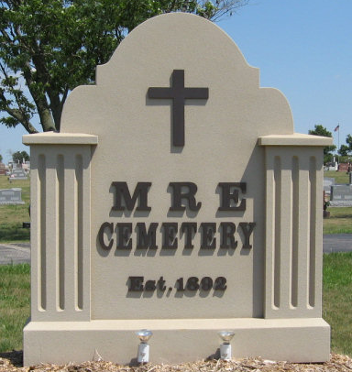
Photo by Tombstoner & Family

Indiana, U.S., WPA Death Index, 1882-1920

Name: Cora Nussbaum
Date: Sept 12, 1894
Location: Adams County
Age: 2 Yr
Gender: Female
Race: White
Source location: County Health Office, Decatur
Source notes: The source of this record is the book H-19 on page 144 within the series produced by the Indiana Works Progress Administration.

**
Cora Nussbaum-gg niece 28A from tree Burch Family Tree
Birth 23 Feb 1892 Berne, Adams, Indiana, USA
Death 12 Sep 1894 Berne, Adams, Indiana, USA
Father Johann Nussbaum (1863-1910)
Mother Mary Ellen Baumgartner (1872-1950)

