Arthur L. Nussbaum
1952 -

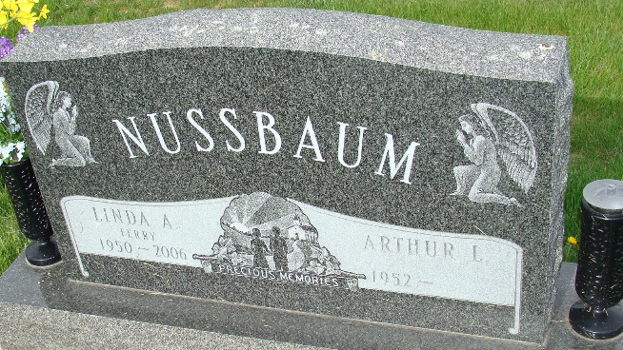
Photo by Alicia Kneuss

