Georgina Ann (Stamper) Newport
July 11, 1954 -

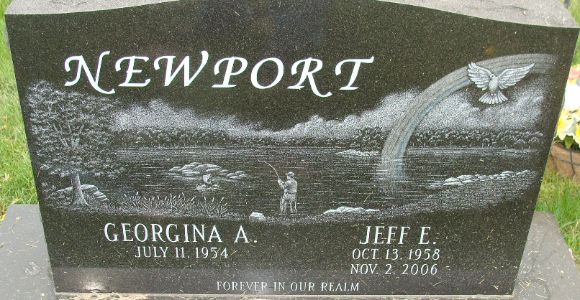
Photo by Alicia Kneuss

Georgina Ann Newport
in the Indiana, U.S., Marriage Certificates, 1960-2012
Name Georgina Ann Newport
Maiden Name Stamper
Gender Female
Birth Place Indiana
Spouse Jeffrey Edwin Newport
Child Elizabeth Ann Vanover
Notes 2 N
Reference Number 1 Bx1451
Reference Number 2 Tr8651
Certificate Number 031689
Volume Number 61-64

