Keith L. Neuhauser
May 4, 1933 – January 11, 2016

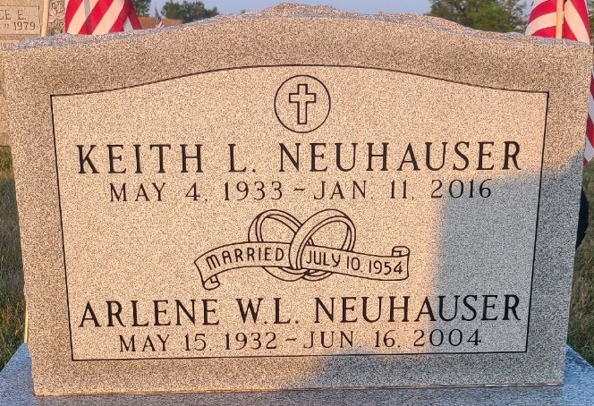
Photo by Jenna Langston

Keith L Neuhauser
in the Indiana, U.S., Death Certificates, 1899-2017
Name Keith L Neuhauser
Gender Male
Race White
Marital Status Divorced
Age 82
Birth Date 4 May 1933
Birth Place Berne, Indiana
Death Date 11 Jan 2016
Death Place Fort Wayne, Allen, Indiana, USA
Death Registration Date 2016
Father Newell Neuhauser
Mother Faye (Oplinger) Clauser
Informant Jane Yoder; cousin; Fort Wayne, Indiana
Cremation Northern Indiana Crematory Corp.; Fort Wayne, Indiana
Certificate Number 001337

