Arlene W. L. (Kent) Neuhauser
May 15, 1932 – June 16, 2004

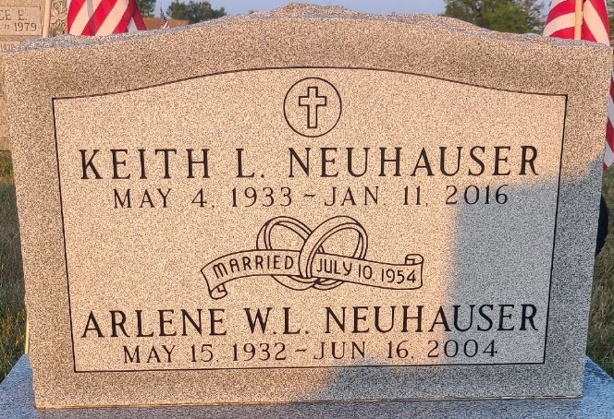
Photo by Jenna Langston

Arlene W L Neuhauser
in the Indiana, U.S., Death Certificates, 1899-2017
Name Arlene W L Neuhauser
[Arlene W L Kent]
Gender Female
Race White
Marital Status Married
Age 72
Birth Date 15 May 1932
Birth Place Jamestown, New York
Death Date 16 Jun 2004
Death Place Indianapolis, Marion, Indiana, USA
Death Registration Date 2004
Father Ruben Kent
Mother Edith Loeb
Spouse Keith Neuhauser
Informant Keith Neuhauser; husband; Indianapolis, Indiana
Cremation June 19, 2004; Flanner & Buchanan Crematory, Indianapolis, Indiana

