Thomas Lynn Neuenschwander
June 24, 1953 – April 24, 1957
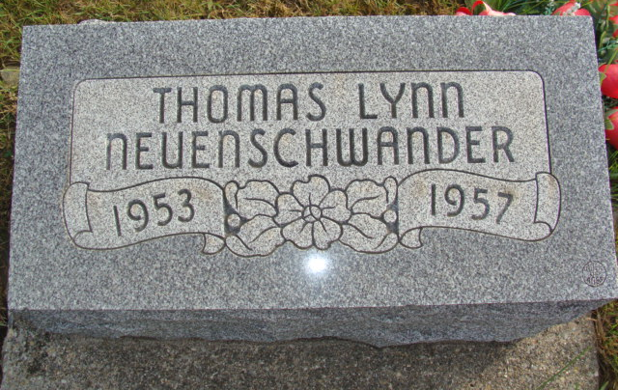
Photo by Alicia Kneuss

Handwritten-Mon. April 27, 1957
Funeral Today For Boy Crushed Under Tractor
Mishap Claims Life of 3-Year-Old Thomas Lynn Neuenschwander
Services were held at 2 p.m. today at the First Mennonite Church for three-year-old Thomas Lynn Neuenschwander, son of Mr. and Mrs. Philip Neuenschwander who was fatally injured Friday when crushed under the wheel of a tractor. Rev. O. A. Krehbiel, pastor of the church, officiated and burial was in the M.R.E. Cemetery.
The child died at 3 p.m. Friday in the office of Dr. Robert Boze, local physician, about 30 minutes after the mishap. The child had a ruptured lung and a crushed liver. The boy was unconscious when rushed to the doctor's office and it was apparent immediately that he was gravely hurt. A resuscitator owned by the local fire department was used but to no avail.
The mishap occurred at the Philip Neuenschwander home a mile south and a short distance east of the tile mill. Mr. Neuenschwander, who in addition to being a farmer is a widely known auctioneer and real estate dealer, was pushing a wagon, partially loaded with hay, into his bank barn with the tractor. The hay had been loaded at his father's farm and the load was to be finished in the Philip Neuenschwander barn. The hay had been sold. While pushing the wagon up the incline the wagon and tractor jackknifed after the two vehicles came close to the south edge of the embankment. The tractor and wagon started to roll backwards in a southwesterly direction toward a trailer standing in the south part of the farm yard.
Glancing backward, Neuenschwander saw his son climbing into the trailer The child had one leg in the trailer, the other on the ground. The tractor struck the trailer a glancing blow, throwing the child off and directly into the path of the tractor. Mr. Neuenschwander made a valiant attempt to miss the child but was unsuccessful, one back wheel of the tractor passing over the child's chest while the boy was lying flat on his back.
The child's grandfather, David P. Neuenschwander, who was standing nearby and who had been assisting his son, picked the child up from the ground and immediately transferred him to the father's arms. He rushed to (missing)
The child was born June 24, 1953, the son of Philip D. and Leona Liechty Neuenschwandrer.
Surviving in addition to the parents are two sisters, Judith Kay, 9, and Patti Joan, 5, and the grandparents, Mr. and Mrs. David P. Neuenschwander and Amos Liechty, all of this community.
Adams County Indiana Historical Museum
1955 Mar-April 1958 Scrapbook, image 98

