Steven J. Neuenschwander
1948 -

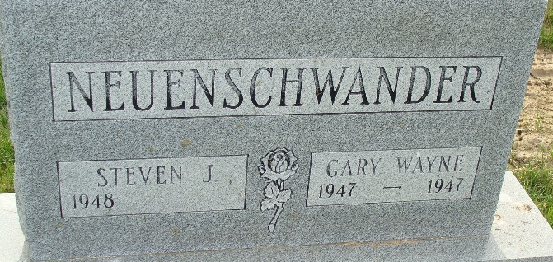
Photo by Alicia Kneuss

