Oliver Edward Neuenschwander
December 22, 1885 - 1886

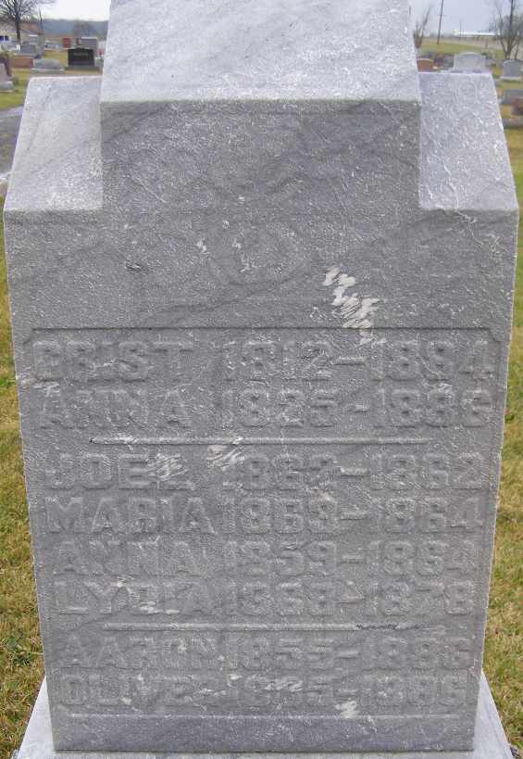
Photo by Shaunda Bedwell

Oliver Edward Neuenschwander from tree My Swiss Roots (Private)
Birth 22 Dec 1885 Berne, Adams, Indiana, USA
No publicly available family members

