Noah Neuenschwander
December 5, 1887 – October 1, 1964

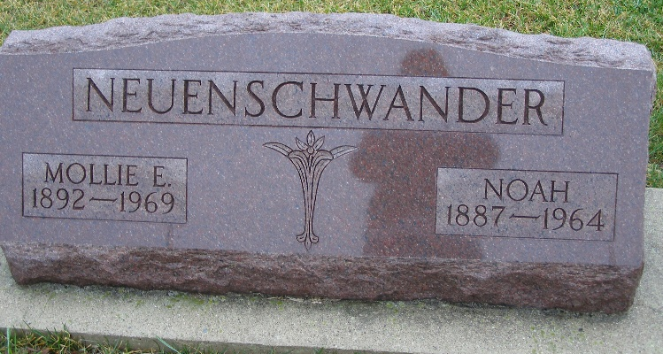
Photo by Shaunda Bedwell Opdycke

Indiana, Death Certificates, 1899-2011

Name Noah Neuenschwander
Gender Male
Race White
Marital Status Married
Age 75
Birth Date 5 Dec Abt 1888
Birth Place Indiana
Death Date 1 Oct 1964
Death Place Decatur, Adams, Indiana, USA
Death Registration Date 1964
Father Christian C Neuenschwander
Mother Maryann Stauffer
Spouse Mollie Neuenschwander, informant
Burial 10/4/1964 MRE

