Lydia Neuenschwander
January 31, 1868 – March 26, 1878

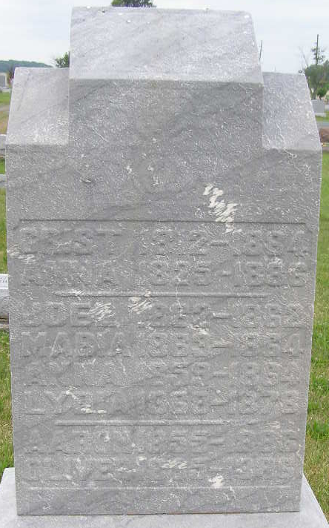
Photo by Shaunda Bedwell Opdycke

Lydia Neuenschwander from tree hawkridge/vaughan
Birth 31 Jan 1868 Monroe City, Adams, Indiana, USA
Residence 1870 Adams, Indiana, USA
Death 26 Mar 1878 Monroe City, Adams, Indiana, USA
Father Christian (Christen) P. Neuenschwander (1812-1884)
Mother Anna Maria Lehman (1825-1886)

