Joel Neuenschwander
June 20, 1862 – July 8, 1862

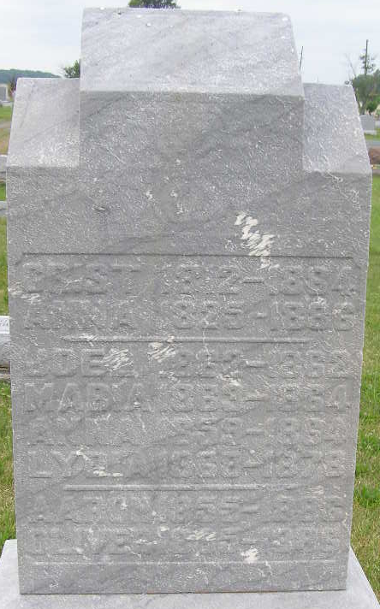
Photo by Shaunda Bedwell

Joel Neuenschwander from tree Miriam Sue Dolislager Family Tree
Birth 20 Jun 1862 Adams, Indiana, USA
Death 8 Jul 1862 Adams, Indiana, USA
Father Christian P Neuenschwander (1812-1884)
Mother Anna Barbara Lehman (1825-1886)
1924 People 1 Record 2 Sources

