Helena (Hirschy) Neuenschwander
July 11, 1886 – May 23, 1918

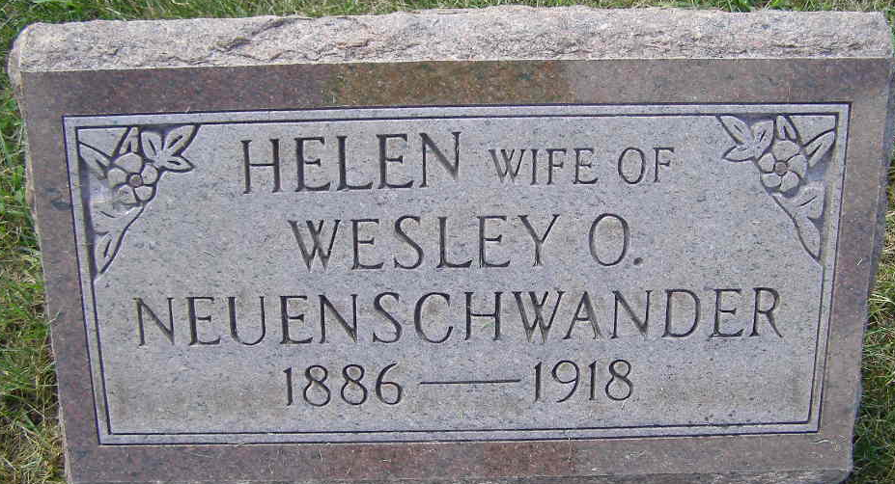
Photo by Shaunda Bedwell

Helena Neuschwander
in the Indiana, U.S., Death Certificates, 1899-2017
Name Helena Neunschwander
[Helena Hirschy]
Gender Female
Race White
Marital Status Married
Age 31
Birth Date 11 July 1886
Birth Place Adams County
Death Date 23 May 1918
Death Place Bane, Adams, Indiana, USA
Death Registration Date 1918
Father Samuel Hirschy
Mother Christina Luginbill
Spouse Wesley Neunschwander
Informant Wesley Neunschwander; Berne, Indiana
Burial May 25, 1918; MRE Cemetery
**

Indiana, Marriage Index, 1800-1941

Name Helena Hirschy
Marriage Date 16 May 1911
Marriage Place Adams, Indiana, USA
Spouse Name W O Neuenschwander

