Christian P. Neuenschwander
November 23, 1812 – November 5, 1884

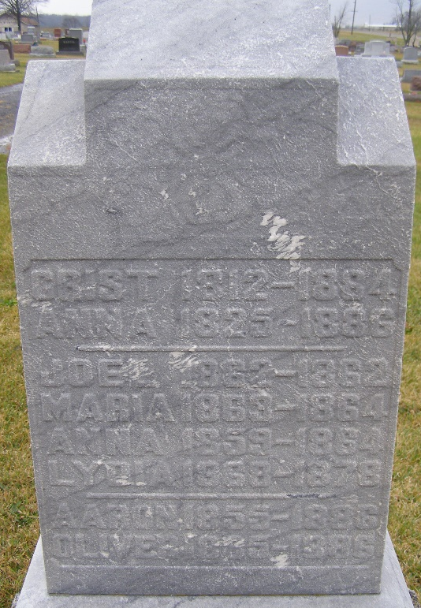
Photo by Shaunda Bedwell Opdycke

Christian (Christen) P. Neuenschwander from tree hawkridge/vaughan
Birth 23 Nov 1812 Bern, Switzerland
Marriage 28 Mar 1854 Wells, York, Maine, USA
Residence 1880 Adams, Indiana, USA
Death 5 Nov 1884 Berne, Adams, Indiana, USA
Father John Neuenschwander (1776-1838)
Mother Katharina Fuhrimann (1782-1853)
Spouse Anna Maria Lehman (1825-1886)

