Anna Maria (Lehman) Neuenschwander
February 23, 1825 – May 28, 1886

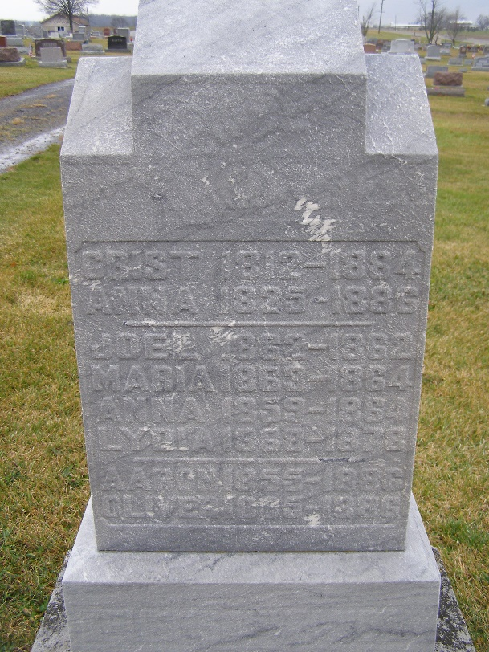
Photo by Shaunda Bedwell

Anna Maria Lehman from tree hawkridge/vaughan
Birth 23 Feb 1825 Moutier, Bern, Switzerland
Marriage 26 Oct 1844 Tramelan, Bern, Switzerland
Residence 1880 Adams, Indiana, USA
Death 28 May 1886 Berne, Adams, Indiana, USA
Father Peter Lehman (1782-1861)
Mother Anna Fuhrimann (1788-1888)
Spouse Christian (Christen) P. Neuenschwander (1812-1884)

