Anna Neuenschwander
January 1, 1859 – August 8, 1864

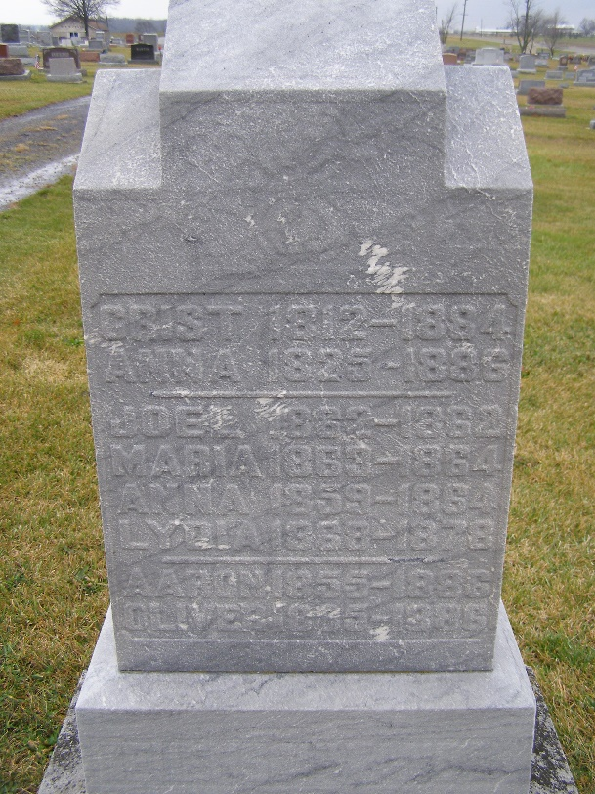
Photo by Shaunda Bedwell

Anna Neuenschwander from tree hawkridge/vaughan
Birth 1 Jan 1859 Monroe City, Adams, Indiana, USA
Residence 1870 Adams, Indiana, USA
Death 8 Aug 1864 Monroe City, Adams, Indiana, USA
Father Christian (Christen) P. Neuenschwander (1812-1884)
Mother Anna Maria Lehman (1825-1886)

