Abraham Neuenschwander
February 1, 1827 – January 28, 1904

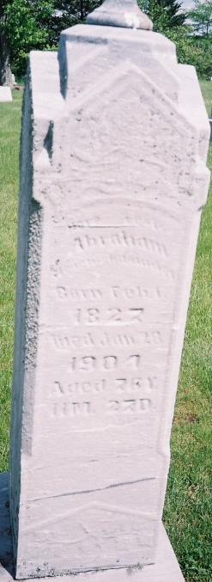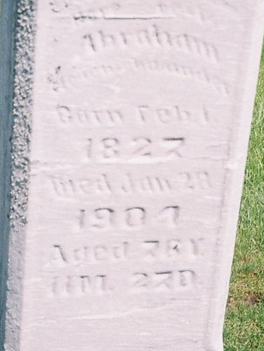
Photo by Steve

Abraham Neuenschwander
in the Indiana, U.S., Death Certificates, 1899-2017
Name Abraham Neuenschwander
Gender Male
Race White
Marital Status Married
Age 76
Birth Date 1 Feb 1827
Birth Place Canton Berne Switzerland
Death Date 28 Jan 1904
Death Place Berne, Adams, Indiana, USA
Death Registration Date 1904
Father Michal Neuenschwander
Mother Unknown
Spouse Amanda
Informant C. A. Neuenschwander; Berne, Indiana
Burial January 31, 1904; MRE Cemetery

**
Abraham Neuenschwander from tree hawkridge/vaughan
Birth 1 Feb 1827 Langnau, Bern, Switzerland
Marriage 20 Sep 1873 Linn Grove, Adams, Indiana, USA
Residence 1900 Adams, Indiana, USA
Death 28 Jan 1904 Berne, Adams, Indiana, USA
Father Michael Neuenschwander (1785-1859)
Mother Barbara Fuhrimann (1784-1850)
Spouse Amanda Kampf (Camp) (1832-1919)

