Louie E. Neaderhouser
January 13, 1880 – July 2, 1955

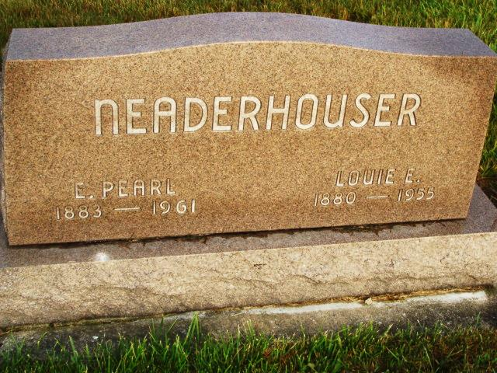
Photo by Alicia Kneuss

NEADERHOUSER

Berne, July 2 – Louis E. Neaderhouser, 75, died early this morning at his home here as the result of a heart attack. He retired in 1943 after serving 35 years as a mail carrier and was a native of Linn Grove. He was a member of the Evangelical United Brethren Church.
Surviving are the widow, Pearl; two sons, George of Fort Wayne and Robert of Berne; a stepson, Newell Rice of Columbia City; a daughter, Mrs. Ed Craven of Bluffton; two sisters, Mrs. Chris Martz of Fort Wayne and Mrs. Albert Stauffer of Markle; six grandchildren and three great-great grandchildren.
The body was removed to the Yager Funeral Home where friends may call after noon Sunday. Services will be conducted Monday at 1:30 pm at the funeral home, with the Rev. Arthur Givens officiating. Burial will be in the MRE Cemetery.
Journal-Gazette, Allen County, Indiana
July 3, 1955, Page 4A
**

Handwritten-Wed. July 6, 1955

LOCAL RETIRED MAIL CARRIER BURIED MONDAY
Louis “Brandy” Neaderhouser Dies Suddenly Early Saturday
One of this community’s best known men is gone.

Louis E. “Brandy” Neaderhouser, 75, died suddenly at 12:15 a.m. last Saturday at his home at 206 Bryan Street. His wife heard him make just a few gurgling sounds and he died almost immediately after being stricken by a heart attack.
Funeral services were held at 1:30 p.m. Monday at the Yager Funeral Home with Rev. Arthur E. Givens, pastor of the Trinity EUB Church of which he was a member, officiating. Burial was in the M.R.E. Cemetery. Local mail carriers and post office employees whom Neaderhouser had been associated during his 35 years as a rural mail carrier, served as pall bearers.
The retired mail carrier had been in ill health for the past nine years, following a heart attack. He recovered sufficiently to be up and around but he was not the same “Brandy” people used to know. He had slowed up a lot and had to take it easy.
Neaderhouser retired in February of 1943, as carrier after 35 years. He began carrying mail back in 1908 during the horse and buggy days. He experienced many hardships during those early years and even after the automobiles were here to stay there were days when he was stuck in the mud or in snowdrifts. He covered hundreds of thousands of miles during his 35 years and was well liked, well respected by his rural customers and scores of families waited eagerly daily for the first sight of the mail carrier. For many years Neaderhouser covered the territory west and north of Berne and in later years, because of a consolidation of mail (missing)
He was born in Linn Grove Jan. 13, 1880, a son of Emmanuel and Carolyn Houser Neaderhouser, and was married to Pearl Holmes Rice Feb. 22, 1910.
Surviving in addition to his wife are two sons, George of Fort Wayne and Robert of Berne; a daughter, Mrs. Ed (Doris) Craven of Bluffton; a step-son, Newell Rice of Columbia City; six grandchildren and three great-grandchildren, and two sisters, Mrs. Chris Martz of Fort Wayne and Mrs. Albert Stauffer of Markle. A brother, Henry preceded in death.

Adams County (IN) Historical Museum
1955 March-April 1958 Scrapbook, image 20

