Emil Adolf Nagel
July 4, 1904 – December 18, 1992

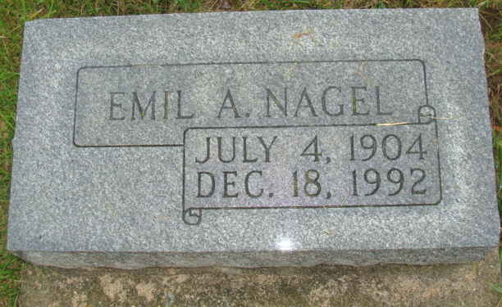
Photo by Alicia Kneuss

EMIL A. NAGEL, 88, of Berne died yesterday in Adams County Memorial Hospital, Decatur. A native of Canton Turgua, Switzerland, he was retired from Berne Furniture Co. and was a former hearing aide salesman.
Surviving are his wife, Wilma; sons, Michael of Valencia, Pa., and Robert of Richmond, Va.; daughters, Susan Ann DuBose of Richmond, Va., and Nancy Fissinger of Vienna, Va.; a stepson, Roger Bricker of Lincoln, Mo.; a sister, Dora McClain of Fort Wayne; four grandchild-ren; three great-grandchildren; and five stepgrandchildren.
Calling will be 2 to 4 and 6 to 8 p.m. today at Yager-Kirchhofer Funeral Home. Calling will also be 11 a.m. to 2 p.m. tomorrow at the funeral home, with services following. Burial will be in M.R.E. Cemetery.
News-Sentinel, The (Allen County, Indiana), December 19, 1992
Page: 7A, FIRST SECTION

