C. August Nagel
June 30, 1903 – January 8, 1981

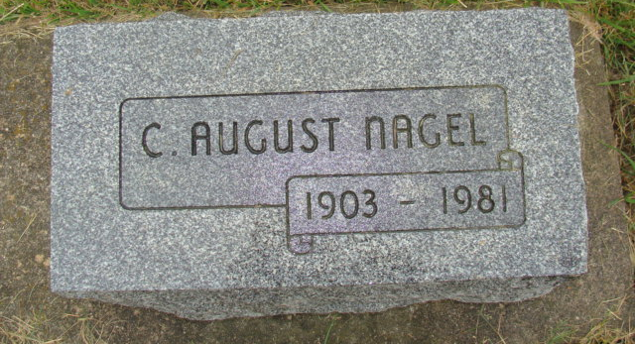
Photo by Alicia Kneuss

Indiana, Death Certificates, 1899-2011
Name: C. August Nagel
Gender: Male
Race: White
Age: 77
Marital status: Widowed
Birth Date: 30 Jun 1903
Birth Place: Switzerland
Death Date: 8 Jan 1981
Death Place: Decatur, Adams, Indiana, USA
Father: Emil Nagel, Sr.
Mother: Mathilda Lehman
Informant: Conrad A. Nagel
Burial: 1-10-1981 MRE

