Albert E. Weaver
June 3, 1872 – August 9, 1963

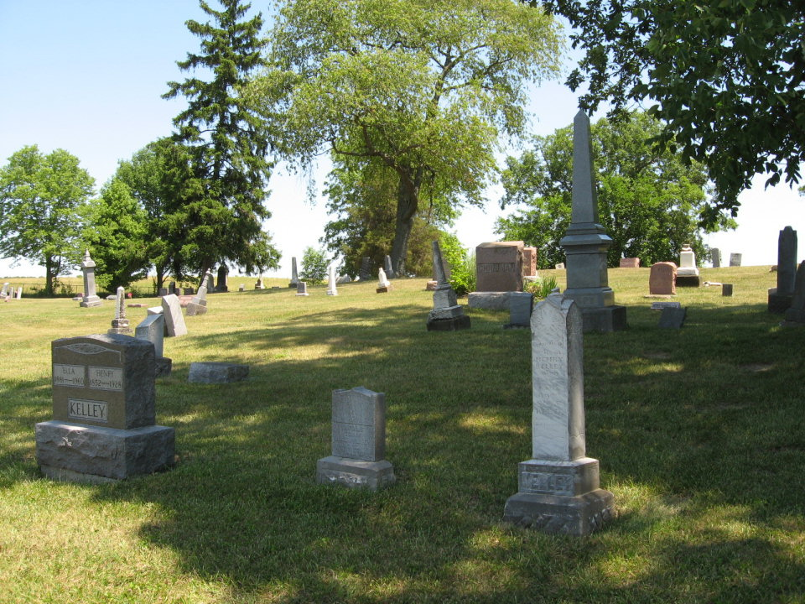
Photo by Tombstoner & Family

Albert E. Weaver Is Taken By Death

Albert E. Weaver, 91, of Geneva, a retired farmer, died Friday at the Berne nursing home. Survivors include a sister and several nieces and nephews.
Funeral rites will be held at 1:30 p.m. Monday at the Church of God in Portland. Burial will be in Bunker Hill cemetery, west of Geneva. Friends may call at the Baird funeral home in Portland from 6 p.m. today until 12 noon Monday.
(Saturday, Aug. 10, 1963)

Berne (IN) Library Heritage Room
Adams County Obits 1962-1964
Transcribed by Janice Vasilovski

