John Franklin Pickering
November 20, 1892 – July 11, 1934

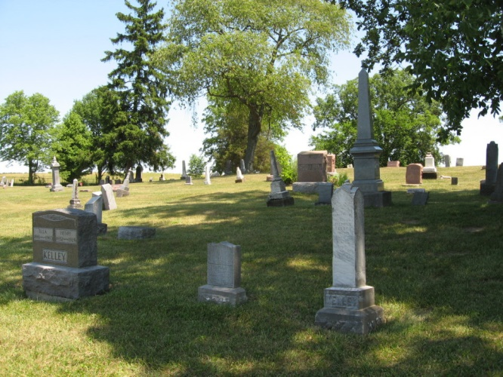
Photo by Tombstoner & Family
CEYLON WORLD WAR VET DIES
Legion to Participate In John Pickering Funeral; Gassed During War

John Pickering, aged 41, of Ceylon, died Wednesday afternoon at 1:30 o'clock at his home. He had been ailing for several years, and was confined to his home the past several months. He was engaged as a railroad section hand before he became sick. Death was caused by tuberculosis and other complications.
Pickering was a World War veteran. He was gassed in one of the many battles in which he participated, and never was well afterwards. He was a Corporal in Company L. 339th Infantry and served in Russia much of the time.
The deceased was born in Mercer County, Ohio, November 20, 1892, a son of Mr. and Mrs. John Pickering. In early life he was married to Blanche Nevil, who survives. One child was born to this union but is deceased. The widow, the father, three sisters and two brothers survive.
The funeral will be held at the U. B. church at Geneva, Saturday afternoon at 2 o'clock, Rev. Frank Johnson of east of Berne officiating. It will be a military funeral, with Adams Post of the American Legion participating. Several members of the Legion from here will attend. Burial will be at Bunker Hill.

Berne Witness, Adams County, IN; July 12, 1934

Contributed by Karin King

