Wilson Mann
October 10, 1826 – July 27, 1911

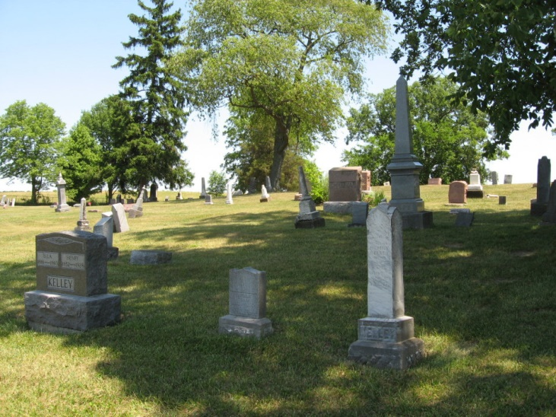
Photo by Tombstoner & Family
WILSON MANN
Wilson Mann was born in Randolph Co., Ind., on Oct. 10, 1826 and departed this life July 27, 1911, aged 84 years, 9 months and 17 days.
He moved to Adams Co. in October 1873 and has been a resident here until he was called to his reward. He joined the Disciple church at Mt. Gillead in early life about the year 1846. After moving to Adams Co., he united with the church at Elm Grove and kept the faith until the death messenger called him home.
He leaves to mourn his departure 1 brother, 1 half-brother, 1 half-sister, 4 children, 31 grandchildren and about 55 great-grandchildren and one great-great-grandchild. His aged companion and 4 children have gone on before.
Funeral services at the home of W. R. Mann Saturday at ten o'clock by Rev. W. L. Waldo of Geneva. Interment at Bunker Hill cemetery.
We desire to thank the neighbors and friends for their kindness during the death and burial of our father.
R. MANN and WIFE
Berne Witness, Adams County, Indiana; Friday, Aug. 4, 1911
Contributed by Karin King

