Jaunita Lucile Lehman
August 21, 1911 – February 5, 1912

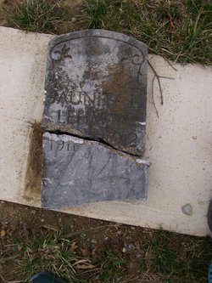
Photo by Scott Shoup

LITTLE JUANITA LEHMAN DIES
A short time after midnight Sunday night Juanita Lucile, little daughter of Mr. and Mrs. Thomas Lehman living on east Water Street across from the grist mill, died of erysipelas and lung complications. Her suffering was agonizing. The deceased was born in Berne, Aug. 21, 1911 and was only 5 months and 13 days old at death. She was a sweet baby and father and mother are grief stricken over the death of their only child.
Funeral will take place this afternoon at 1:00 p.m. at the home. Interment at Bunker Hill Cemetery.
Berne Witness, Adams County, IN; February 6, 1912

Contributed by Karin King

