Clarence McMurty Winters
May 28, 1884 – January 17, 1941

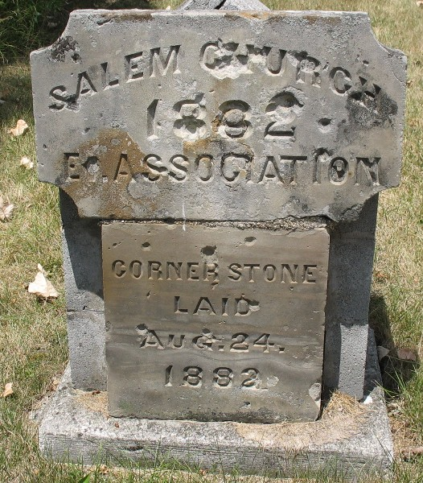
Photo by Tera

DEATH CLAIMS CITY WORKER
Clarence Winters Dies This Morning After Five Weeks’ Illness

Clarence Winters, 56, an electrician at the municipal light and power plant died this morning at 1 o’clock at his home, 519 Jefferson street. Death was caused by complications following an illness of five weeks.
The deceased was born in Decatur May 28, 1884, the son of George and Eliza Worden Winters. He was married to Rose Damon May 8, 1907.
He was a member of the Presbyterian church here. He had lived in this city for seven years after returning from Jonesboro, Arkansas, where the family lived for a number of years.
Mr. Winters served in the Red Cross ambulance corps during the World War.
Surviving besides the widow are a son, Donald Winters of Kokomo, and a sister, Mrs. Mary McClure of Decatur. One sister is deceased.
Funeral services will be held Monday afternoon at 2 o’clock at the residence with the Rev. George O. Walton officiating. Burial will be in the East Salem cemetery.
The body will be returned to the residence from the Black funeral home Saturday afternoon and may be viewed there after 1 p.m. until time for the services Monday.

Unknown source

