Eva L. Draper
July 3, 1883 – April 19, 1902

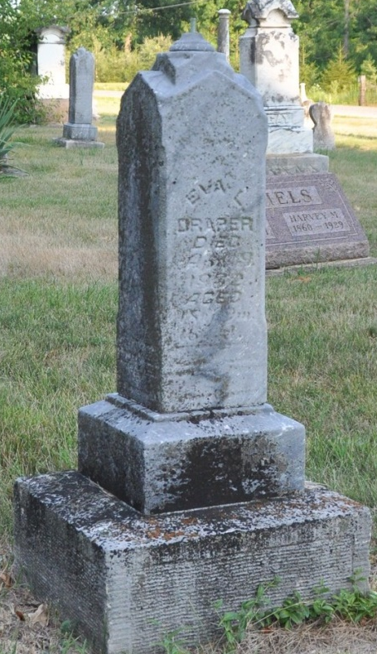
Photo by Deb Curry

Indiana, Death Certificates, 1899-2011

Name: Eva L Draper
Gender: Female
Race: White
Age: 18y 9m 16d
Marital status: Single
Birth Date: 3 Jul 1883
Birth Place: Preble Tpt Ind
Death Date: 19 Apr 1902, tuberculosis
Death Place: Preble, Adams, Indiana, USA
Father: Jeremiah Draper
Mother: Mary Haggard
Informant: Susan Hays, Rockford, Ohio
Burial: April 23, 1902 E. Salem ch.

