Uriah Everhart Cramer
April 9, 1851 – August 25, 1934

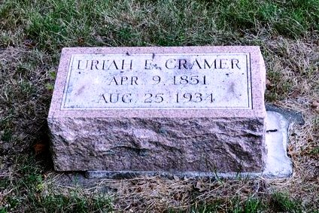
Photo by Deb Curry

Adams Public Library System (Decatur, IN) online obit abstracts

Publication: Decatur Daily Democrat; Date: 27 AUG 1934
Title: Cramer, Uriah Everhart
Subject: Obituaries – C -- 1930-1939
Abstract: Age 83
Died: Monday, August 27, 1934 at his home of complications.
*****

Indiana, Death Certificates, 1899-2011

Name: Uriah Eberhard Cramer
Gender: Male
Race: White
Age: 83y 4m 16d
Marital status: Married
Birth Date: 9 Apr 1851
Birth Place: Indiana
Death Date: 25 Aug 1934
Death Place: Decatur, Adams, Indiana, USA
Father: John Cramer
Mother: Elizabeth Bayless
Spouse: Mary Cramer
Informant: Mary M Cramer, Decatur, Ind
Burial: Aug 28, 1934 East Salem

