Mary Elizabeth (Cramer) Chronister
August 8, 1831 – July 26, 1906

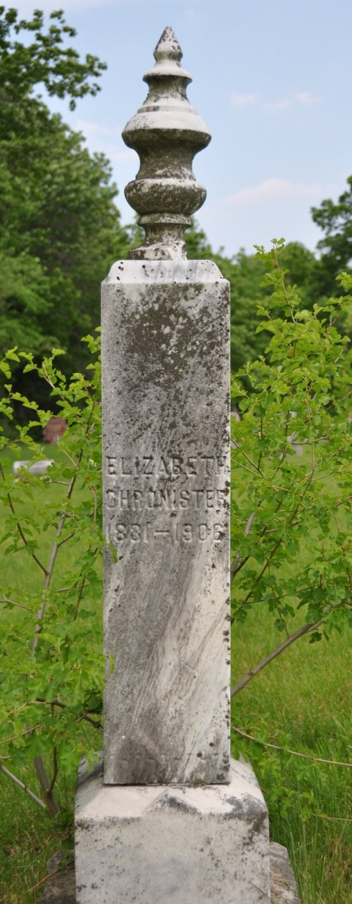
Photo by Deb Curry
WAS SEVENTY-FIVE YEARS OLD
Had Resided Here For Half a Century - Will Be Buried At Salem

Mrs. Mary Elizabeth Chronister, one of the oldest and most respected ladies of our city, died at six o'clock Thursday at her home on Twelfth Street, after an illness of several months, death resulting from old age and other infirmities. She was born in Pennsylvania August 8, 1831, thus making her age at the time of her death, seventy-four years, eleven months and eleven days. She resided in Pennsylvania until she was united in marriage to Mr. Chronister, who has preceded her in death, when they moved to this county, where she resided until the time of her death. She was a kind woman and was well respected in the community, being a loving mother and kind neighbor. She was a member of the M. E. church, and was a devoted Christian and earnest worker in behalf of the church.
The funeral arrangements have not been completed, but interment will be made in the Salem Cemetery.

Decatur Democrat, Adams County, Indiana
(a weekly newspaper)
Thursday, July 26, 1906

*****
OBITUARY OF MRS. CHRONISTER

Elizabeth Cramer was born in Cumberland County, Pennsylvania August 8, 1831, and died in Decatur, Indiana, July 19, 1906, aged 74 years, 11 months and 11 days.
She came to Adams County with her parents in 1849, where soon after she was united in marriage to Jacob Chronister. To this union were born seven children, three of whom preceded her in death. Mr. Chronister died in 1891.
There remains to part with a kind, loving mother, two sons, John and Isaac, and two daughters, Anna and Caroline, now Mrs. Daugherty.
The closing hours of her life spoke volumes of her relation to her God. She gave evidence of having the earnestness of spirit which assured her that should this house of her tabernacle be dissolved, she has a building of God, a house not made with hands, eternal in the heavens.

Decatur Democrat, Adams County, Indiana
(a weekly newspaper)
Thursday, July 26, 1906

