Martha (Bultemeier) Schamerloh
April 2, 1887 – May 4, 1963

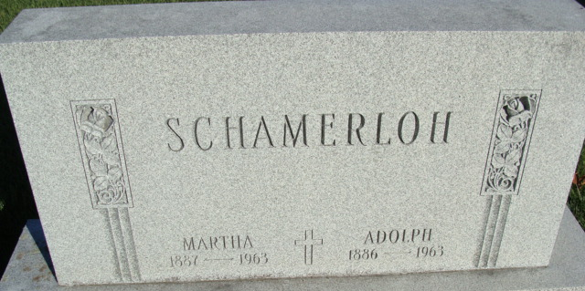
Photo by Alicia Kneuss

Martha Schamerloh Dies This Morning

Mrs. Martha Schamerloh, 76, wife of Adolph Schamerloh, 1010 West Monroe Street, died suddenly at 8:20 o’clock this morning at the Adams County Memorial Hospital, where she had been a patient one day. She had been ill for the past year, but death was unexpected.
Born in Root township, April 2, 1887, she was a daughter of Fred and Anna Schroeder-Bultemeier, and was married to Adolph Schamerloh, Oct. 23, 1910.
Mrs. Schmerloh was a member of the Zion Lutheran Church.
Surviving in addition to her husband are one daughter, Mrs. Robert (Margaret) Ashbaucher of Decatur; two sons, Fredrick Schamerloh of Decatur, and Arthur Schamerloh of Fort Wayne; six grandchildren; two great-grandchildren; five sisters, Mrs. Martin (Ida) Aumann of Decatur route 1, Miss Louise and Miss Emma Bultemeier, both of Decatur route 1, Mrs. Paul (Marie) Reiter of Fort Wayne, and Mrs. Edwin (Sophie) Schamerloh of Decatur route 5, and two brothers, Martin and Henry Bultemeier, both of Decatur route 1.
The body was removed to the Zwick Funeral Home, where friends may call after 7 p.m. Sunday. Funeral arrangements have not been completed.

Zwick Funeral Home, Adams County, Indiana
Saturday, May 4, 1963
**
Indiana, U.S., Death Certificates, 1899-2017
Name Martha Schamerloh
[Martha Bultemeier]
Gender Female
Race White
Age 76
Marital Status Married
Birth Date 2 Apr 1887
Birth Place Indiana
Death Date 4 May 1963
Death Place Decatur, Adams, Indiana, USA
Death Registration Date 1963
Father: Fred Bultemeier
Mother: Anna Schroeder
Informant: Adolph Schamerloh; husband; Decatur, Indiana
Burial: May 7, 1963; Immanuel Lutheran Cemetery; Decatur, Indiana

