Anna (Bohnke) Railing
April 5, 1874 – November 30, 1969

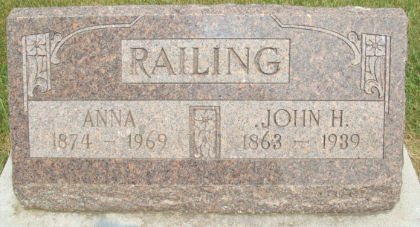
Photo by Alicia Kneuss

DECATUR, Ind. – Mrs. Anna Railing, 95, of Decatur, died at 8:05 p.m. Sunday in Adams County Memorial Hospital, where she had been a patient for 10 days.
Mrs. Railing was born April 5, 1874, in Adams County, the daughter of Frederich and Whilamina (Lagerman) Bohnke. She was married Nov. 25, 1893, to John H. Railing, who died in 1939.
Mrs. Railing was the oldest member of the Immanuel Lutheran Church of rural Decatur and was affiliated with the Ladies Aid Society of the church.
Surviving are four daughters, Mrs. Ernest (May) Thieme and Mrs. Edgar (Esther) Reinking, both of Decatur, Mrs. Carl (Louesa) Whittenbarger of Fort Wayne and Mrs. Cletus (Linnie) Buechner of 1006 Haley St.; a sister, Miss Alvena Bohnke of Decatur and a brother, August, also of Decatur; seven grandchildren and 16 great-grandchildren. A son, Alva, is deceased.
Funeral services will be at 12:30 p.m. Wednesday at Zwick Funeral Home, Decatur and at 1 p.m. at the Immanuel Lutheran Church, with the Rev. Ronald Michel officiating. Burial will be in the church cemetery. Friends may call at the funeral home after 7 p.m. today.

Van Wert Times Bulletin, Van Wert County, Ohio
Monday, December 1, 1969

