Fritz Heinrich Mueller
June 27, 1917 – June 22, 2007

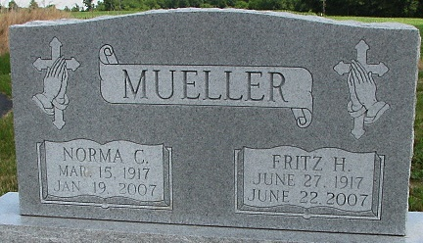
Photo by Alicia Kneuss

Fritz H. Mueller, 89, formerly of Decatur, died Friday, June 22, 2007, in Gross-Gerau, Germany. Born on June 27, 1917, in Frankfurt, Germany, he worked in manufacturing of stainless-steel merchandise for Kalle Hochst in Germany, retiring in 1980. He was also a member of Zion Lutheran Church, Decatur.
Surviving is one son; and three foster children, all in Germany; three sisters-in-law, Florence Bulmahn of Ossian, Edith Nierman of Van Wert, Ohio, and Edna Mesing of Decatur; three brothers-in-law, Herbert Marbach, Edward Marbach and Richard Marbach, all of Decatur; and two grandchildren. He was preceded in death by his first wife, Alma Amalie Volkmar, in 1980, whom he married Dec. 29, 1939, in Germany; and second wife, Norma C. Marbach Selking Emerick, on Jan. 19, 2007, whom he married on Dec. 3, 1983, in LaBelle, Fla.; sister, Else Zuber; and sister-in-law, Linda Brenneke.
Service is 10:30 a.m. Tuesday at Immanuel Lutheran Church 'Union", east of Decatur, with visitation one hour prior. The Rev. Daniel J. Gadbaw officiating. Visitation also from 4 to 8 p.m. Monday at Elzey-Patterson-Rodak Funeral Home, 120 W. Mill St., Ossian. Burial in Immanuel Lutheran Cemetery.
Memorials to Zion Lutheran Radio Ministry, Immanuel Cemetery Fund or donor's choice.

News-Sentinel, Allen County, Indiana
Sunday, July 1, 2007
**

U.S., Social Security Applications and Claims Index, 1936-2007
Name Fritz Heinrich Mueller
[Fritz H Mueller]
Gender Male
Race White
Birth Date 27 Jun 1917
Birth Place Frankfurt, Federal Republic of Germany
Death Date 22 Jun 2007
Father: [No Name]
Mother: Katharina Mueller
SSN xxx
Citizenship or Alien Status Legal alien not authorized to work.
Type of Claim Alien not authorized to work.
Notes 22 Dec 1983: Name listed as FRITZ HEINRICH MUELLER; 07 Jul 2007: Name listed as FRITZ H MUELLER

