William H. Holle
November 11, 1848 – July 20, 1928

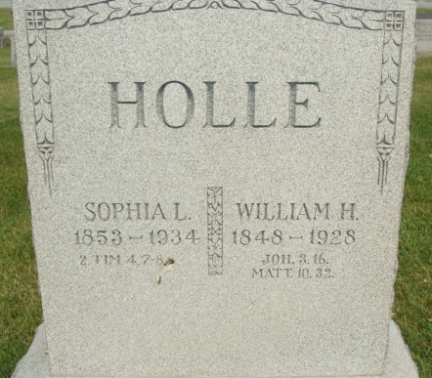
Photo by Alyssa Kneuss

Indiana, Death Certificates, 1899-2011

Name: William Holle
Gender: Male
Race: White
Age: 79y, 8m, 9d
Marital status: Married
Birth Date: 11 Nov 1848
Birth Place: Germany
Death Date: 20 Jul 1928
Death Place: Ft Wayne, Allen, Indiana, USA
Father: Henry Holle
Mother: Louise Kottler
Spouse: Sophia Holle, informant
Burial: July 24, 1928, Union, Adams Co

**
WILLIAM HOLLE.

William Holle, of Union Township, is a native of the fatherland, having been bornin Prussia, Germany, on November 11, 1848. His parents were Henry and Louise (Kettler) Holle, also natives of Prussia, who emigrated to America in 1857. They came at once to Adams County and for three years lived on rented land in Root Township. In 1861 Mr. Holle purchased eighty acres of timber land, which he cleared and improved and developed into one of the best farms of the locality. Here they lived until their deaths, the father dying August 8, 1897, at the age of seventy-eight years, and the mother in January, 1905, when upwards of eighty years of age. They were the parents of six children: William, Frederick, Engel, who died when about three years old; Louise, the wife of W. F. Bleeke; Sophia, the wife of Frederick Thieme, but who is now deceased, and Emma, the wife of Martin Bleeke.
The subject of this sketch was nine years of age when the family came to America and he spent his young manhood in Root Township, this county, living with his father until 1875, when he settled on the farm where he now resides. He has devoted much of his attention to the cultivation of his farm, but during the past thirty years has given much attention to the sawmill business, in which he has been equally successful.
On September 19, 1875, Mr. Holle married Miss Sophia Bleeke, a daughter of Christian and Louise (Fahlsing) Bleeke, and to this union have been born ten children: Johanna, the wife of William Koldewey, but who died at Ft. Wayne, Indiana, on February 12, 1906; Martin, deceased; Henoch, a minister at Omaha, Nebraska; Charles, who died at the age of four years; Justinus, Otto, Matilda, Ludella, Lucy and Lona.
Mr. and Mrs. Holle are members of the Emanuel Lutheran Church, in which he has been trustee, and when the church was erected he was president of the building committee, and thus was closely associated with this enterprise. He has many fine qualities of character and justly merits the high regard which is bestowed upon him by those who know him. Mr. Holle owns one hundred and twenty acres of land in section 16, where he resides, and owns a farm of one hundred acres in section 9, Union Township.

Snow's History of Adams County, Indiana, John Fletcher Snow, B. F. Bowen, Indianapolis, IN, 1907, p. 234

