Henry Blakely
February 17, 1855 – November 6, 1933

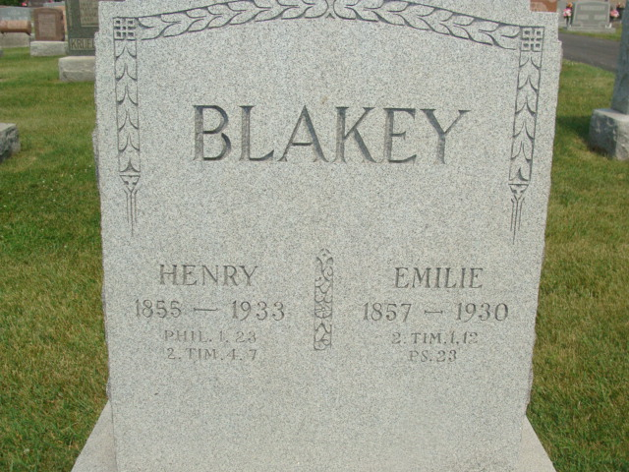
Photo by Alicia Kneuss

Indiana, Death Certificates, 1899-2011

Name: Mr John Henry Blakey
Gender: Male; Race: White; Age: 78y, 8m, 19d
Marital status: Widowed
Birth Date: 17 Feb 1855; Birth Place: Indiana
Death Date: 6 Nov 1933; Death Place: Fort Wayne, Allen, Indiana
Father: Christ Blakey; Mother: Marie Fahlsing
Informant: John W. Blakey of Decatur, IN
Burial: Nov 9, 1933; Bleeke Cem
*****

JOHN H. BLAKEY.

John H. Blakey, who has spent his entire life in Union township, Adams county, Indiana, where he is now successfully following agricultural pursuits, was born in this township on February 17, 1855. His parents were Christian F. and Louisa (Fhalswg) Blakey, natives of Prussia. Christian Blakey came to Adams county, Indiana, in 1836 and was married here in 1850. This couple resided here during the remainder of their lives, the father dying at the age of seventy-eight years and the mother at the early age of twenty-three. They were the parents of three children: Mary L., the wife of H. F, Reinking; Sophia, the wife of William Holle; John H., the subject. After the death of his first wife Mr. Blakey married Miss Mary Rupp and to this union were born the following children: Christian, who died in childhood; Eliza, who died at the age of twenty-four years; Charles, Fred (deceased), Martin, Theodore, Edward C, Matilda, the wife of Adam Bentz, and Otto.
John H. Blakey was reared on his father's farm and during his youth obtained a fair education in the common schools. He early gave attention to the labors of the farm, assisting his father in clearing and cultivating the land, and has always been considered among Union township's practical men. He owns two hundred and twenty acres of as good land as can be found in the township and gives his every effort to maintain it at a high standard.
On September 29, 1878, in Union township, Mr. Blakey married Miss Amelia Thieme, who was born in Fort Wayne on May 23, 1857, the daughter of Godfrey and Amelia (Roscher) Thieme, who emigrated to this country from Saxony, Germany, locating in Union township, where they died at the respective ages of seventy and sixty-seven years. To the subject and his wife have been born eleven children : Julia A., the wife of Frank Kirbach; Arthur C, Adelia, who died at the age of eight years; Amelia, John, Christian, Clara, Louise, Lydia, Rosa, who died at the age of two years, and Henry. Mr. Blakey takes a deep interest in local public affairs and has always voted with the Democratic party. He and his wife are members of the German Lutheran church and are highly respected in the community.

Snow's History of Adams County, Indiana, John Fletcher Snow, B. F. Bowen, Indianapolis, IN, 1907, p. 347 (image 711)

