Louisa (Rhodes) Bittner
July 31, 1856 – April 2, 1901

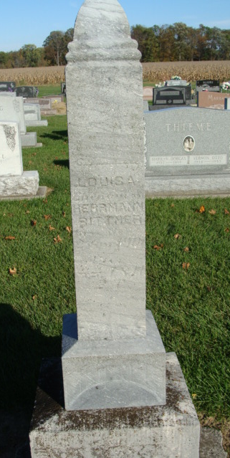
Photo by Alicia Kneuss

Mrs. Louisa Bittner, wife of Harmon Bittner, died very suddenly on Tuesday of last week of heart trouble.
Her funeral was held at the Blakey church last Wednesday. Interment in the Blakey (sic) Cemetery.

Decatur News, Adams County, Indiana
A weekly newspaper
Wednesday, April 10, 1901

**
Indiana, Death Certificates, 1899-2011

Name: Louisa Bitner
Age: 44 years, 8 months, 2 days
Marital status: Married
Birth Date: abt 1857;
Birth Place: Germany
Death Date: 2 Apr 1901
Death Place: Union, Adams, Indiana, USA
Father: Rhodes
Informant: H. E. Bitner
Burial: April 4, 1901; German Lutheran Cem., Adams Co.

