Margret (Wysup) Yager
February 1, 1813 – January 6, 1887

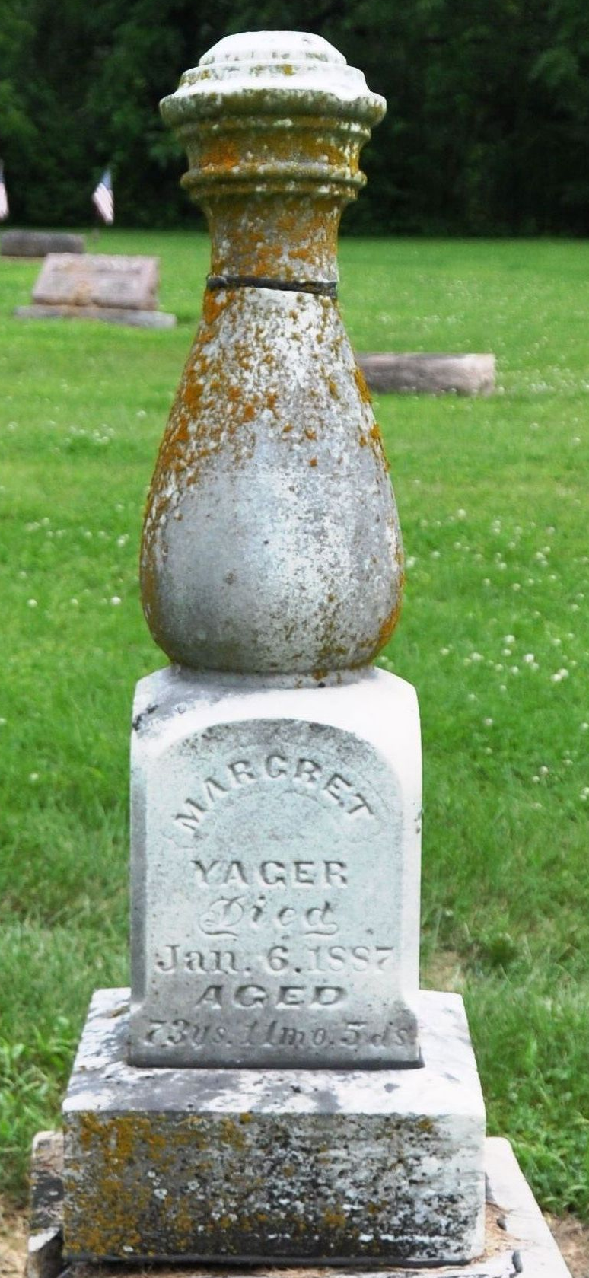
Photo by Deb Curry

Margaret Wysup from tree Johnson Family Tree
Birth Feb 1, 1813 OR 1814 Pennsylvania, USA
Residence 1880 Decatur, Adams, Indiana, USA
Marriage Ohio, USA
Death 6 Jan 1887
Spouse Jacob Yager (1806-1886)

