Kansas “Kannie” (Steele) Yager
September 27, 1868 – November 30, 1894

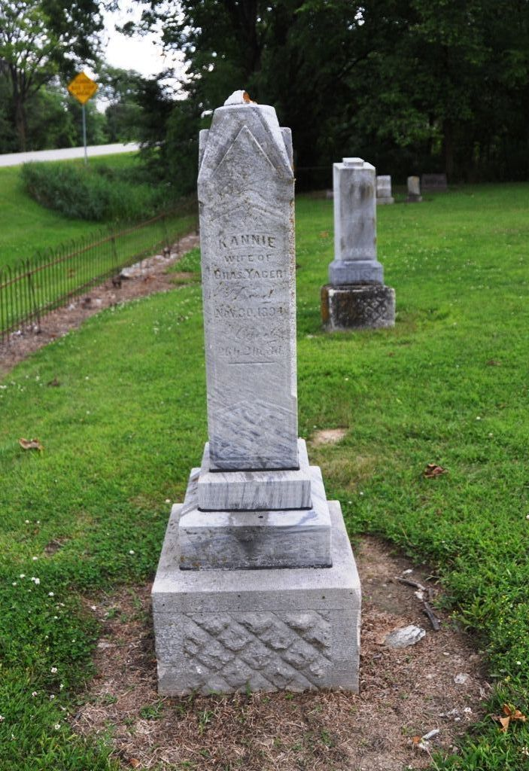
Photo by Deb Curry

OBITUARY
Kansas K., daughter of Samuel and Polly Steele, was born September 27, 1868 and died Nov. 30, 1894, aged 26 years, 2 months and 3 days.
She was baptized by Rev. U. H. Galiant in January 1886 and united with the Pleasant Mills Baptist Church of which she remained a faithful member until called from the church militant to the church triumphant.
December 12, 1889 she was united in marriage with Charles Yager by Rev. D. B. Beckard. Strong was the love which bound these two hearts together and made them one, but it was not strong enough to prevent the onward march of the Angel of Death, who, we are told loves a shining mark.
One son, Milton, who is now 22 months old was born to them.
For years she has fought against that dread disease, consumption, but at last strength gave way and she saw that it was the Lord's will that she should go, then like a submissive child she yielded to the Father's will. As the time drew near she became anxious to go. "Oh let me go home to be with Jesus," she would say. Death had no terrors for her. She made arrangements for her funeral as calmly as if giving directions about the ordinary affairs of life. She could scarcely wait for the Master to come for her. At about 5 o'clock Friday evening she passed peacefully away to the home on high. Three sisters had preceded her to the better land.
Her sorrows and suffering are over; her trials are past. The race is run; the victory won. She is not dead, but sleeps, we believe, in Jesus. A sleep in Jesus is a blessed sleep from which none ever wakes to weep.
The funeral services were held at the Baptist church at Pleasant Mills last Sunday morning, the pastor preaching the sermon from John 14:1, and Rev. Freeland assisted in the service.
A large number of relatives and friends followed the form of the loved one to its resting place in the Pleasant Mills Cemetery.
Another of the members of the church is gone. Another home is desolate, but out of the gloom and the darkness we can hear the Master's voice: "It is I, be not afraid." "What I do thou knowest not now; but thou shalt know hereafter." "Let not your heart be troubled; ye believe in God, believe also in me."

Decatur Democrat, Adams County, Indiana
A weekly newspaper
Friday, December 7, 1894

