Jacob Yager, Sr.
1808 – June 16, 1886

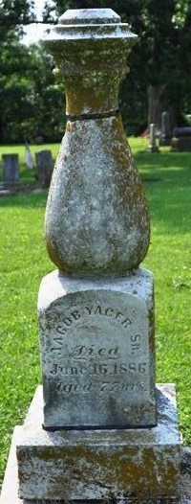
Photo by Deb Curry

Jacob Yager from tree LClasenFamily
Birth 1808 Pennsylvania, USA
Marriage Ohio, USA
Death 16 Jun 1886 Indiana, USA
Father John Yager
Spouse Margaret Wysup (1810-1887)

