Ida May Yager
September 9, 1876 – March 1, 1880

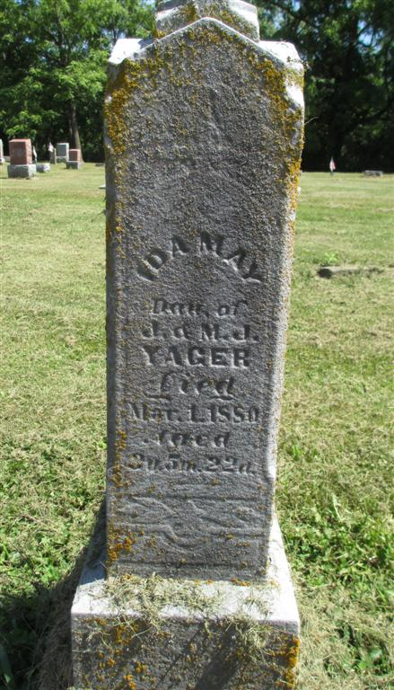
Photo by Deb Curry

Ida May Yeager from tree Love Family Tree
Birth (8 Sep- 11 Sep) 1876 Adams, Indiana, USA
Death 1 Mar 1880 Adams, Indiana, USA
Father Jacob Yager (1837-1904)
Mother Mary Jane Archbold (1841-1911)

