Victoria A. (Steele) Worden
June 22, 1866 – March 22, 1885

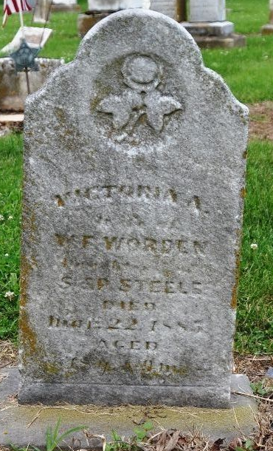
Photo by Deb Curry

Victoria A Steele from tree Helm & Lammert
Birth 22 Jun 1866 Indiana, USA
Residence 1880 Adams, Indiana, USA
Marriage 13 Jan 1883 Adams, Indiana, USA
Death 22 Mar 1885 Adams, Indiana, USA
Father Samuel Steele (1834-1909)
Mother Mary L. "Polly" McCrista (1838-1907)
Spouse William Fletcher Worden (1861-1939)

