Unknown Winans
February 3, 1881 – April 16, 1883

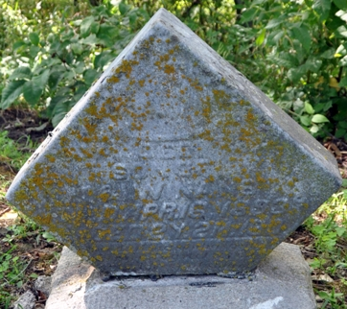
Photo by Deb Curry

No further information found at this time

