Rosa Belle (Flagg) Winans
October 14, 1827 – March 6, 1863

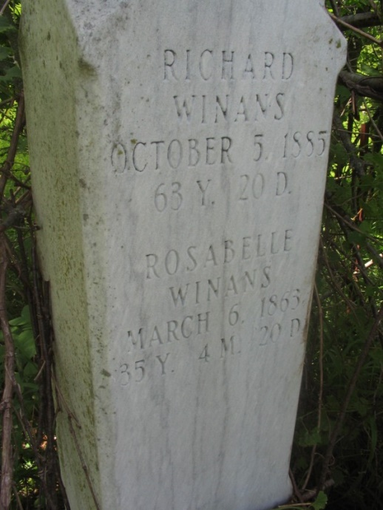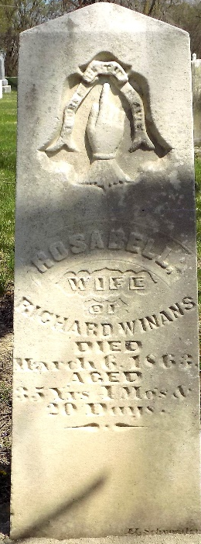
Photo by Margie Roop Pearce

Rosa Belle Flagg Winans from tree stephanie Winans Family Tree
Birth 14 Oct 1827 New York, USA
Marriage 1848
Residence 1860 Adams, Indiana, USA
Death 6 Mar 1863 Pleasant Mills, Adams, Indiana, USA
Father Samuel Flagg Jr. (1801-1882)
Mother Rebecca Flagg (1804-1860)
Spouse Richard Hugh Winans (1822-1885)

