Joseph Ross Winans
February 15, 1817 – April 10, 1878

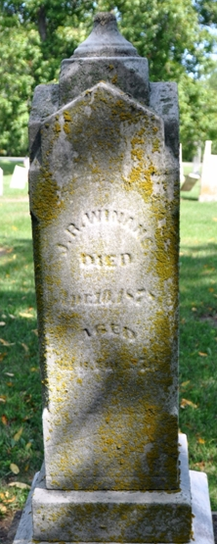
Photo by Deb Curry

Joseph Ross Winans from tree Kathleen Caldwell Severance Family Tree
Birth 15 Feb 1817 Piqua, Miami, Ohio, USA
Marriage 20 Oct 1838 Allen, Indiana, USA
Residence 1870 Pleasant Mills, Adams, Indiana, USA
Death 10 Apr 1878 Adams, Indiana, USA
Father Benjamin Britton Winans (1775-1868)
Mother Sarah Jane Ross (1781-1848)
Spouse Nancy Heath (1820-1899)

