Joseph Dayton Winans
January 27, 1858 – August 28, 1929

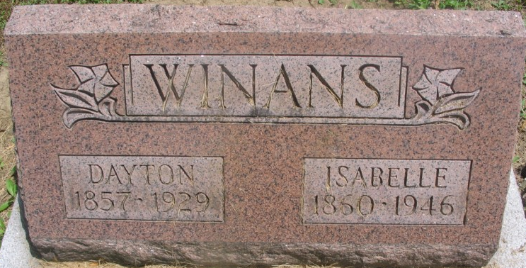
Photo by Margie Roop Pearce

DAYTON WINANS EXPIRES TODAY
Native of St. Mary’s Township Dies Following Paralytic Stroke
Joseph Dayton Winans, 71, lifelong resident of St. Mary’s Township died at 11 o'clock this morning at this home near Pleasant Mills. Mr. Winans had suffered three paralytic strokes the last few years, the third one being the direct cause of his death.
Mr. Winans was well known in the southeastern part of Adams County, where he spent his entire 71 years of life. He was a devoted member of the Pleasant Mills Methodist Church.
Joseph D. Winans was born in St. Mary’s Township January 27, 1858. On November 22, 1881, he was married to Isabel Archer, who survives. The wedding ceremony was performed by the Rev. Mr. Schenck. Three sons also survive. They are Elmer E. Winans, Northport, Wash.; Dick Archer Winans, Farrys, B. C.; Raymond J. Winans, Morris, Oklahoma.
Three children preceded the father in death. They were Ora Ethel, Susie Ozella and Leo H.
Funeral services will be held at the Pleasant Mills Methodist Church, but the date has not yet been announced. The Rev. A. E. Burk, pastor of the Pleasant Mills Methodist Church will have charge of the services and burial will be made at the Pleasant Mills Cemetery.

Decatur Daily Democrat, Adams County, Indiana
Wednesday, August 28, 1929

**
Joseph Dayton Allimans
in the Indiana, U.S., Death Certificates, 1899-2017
Name Joseph Dayton Allimans
[Joseph Dayton Winans]
[Joseph Dayton Winans]
Gender Male
Race White
Marital Status Married
Age 71
Birth Date 27 Jan 1858
Birth Place Indiana
Death Date 28 Aug 1929
Death Place Saint Marys, Adams, Indiana, USA
Death Registration Date 1929
Father Richard Winans
Mother Rosebell Flagg
Spouse Isabelle
Informant Isabelle Winans; Decatur, Indiana
Burial August 31, 1929; Pleasant Mills Cemetery

