Nora M. Wilson
August 17, 1891 – April 21, 1892

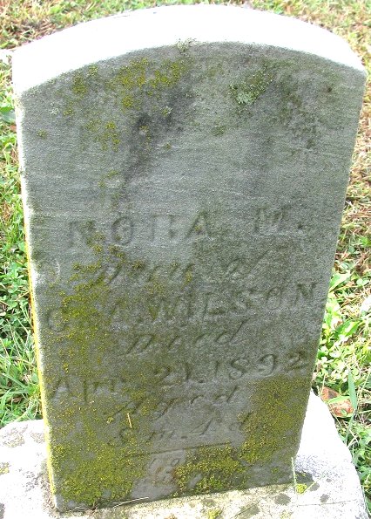
Photo by PLS

No further information found at this time

