Nancy T. Wilson
January 27, 1896 – September 2, 1899

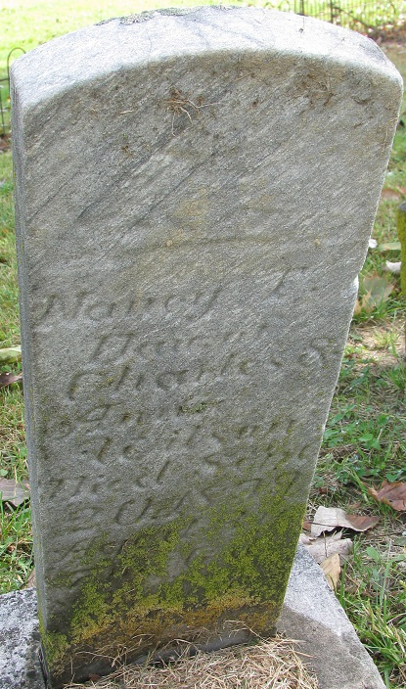
Photo by PLS

No further information found at this time

