Edgar H. Weimer
December 2, 1852 – August 13, 1866

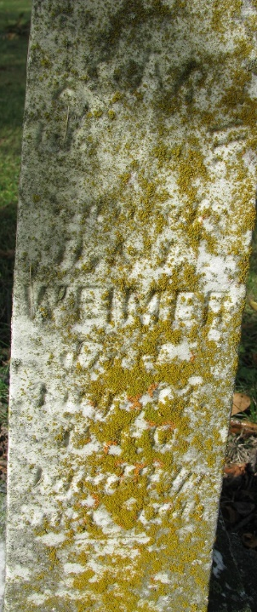
Photo by PLS

Edgar H. Weimer from tree Holloway Family Tree
Birth 2 Dec 1852
Death 13 Aug 1866 Allen, Indiana, USA
Father Daniel Weimer (1814-1861)
Mother Easter White (1822-1909)

