Easter (White) Weimer-Avery
October 14, 1822 – October 7, 1909

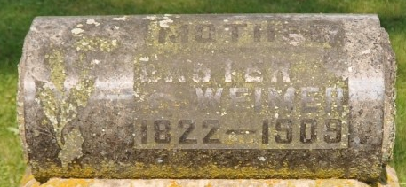
Photo by Deb Curry

Indiana, Marriages, 1810-2001

Name: Esther Weimer
Gender: Female
Event Type: Marriage Registration (Marriage)
Marriage Date: 21 Sep 1868
Marriage Place: Indiana, United States
Spouse: William Avery
Page: 206; FHL Film Number: 002321470

**
Collection: Ohio Deaths 1908-1953

Name: Easter Weimer
Death date: 07 Oct 1909
Death place: Willshire, Van Wert, Ohio
Birthdate: 14 Oct 1822
Birthplace: Ohio
Age at death: 86 years 11 months 23 days; Gender: Female
Marital status: Widowed
Race or color: Caucasian
Occupation: Housekeeper
Burial date: 10 Oct 1909
Burial place: Pleasant Mill Cem
Father's name: Otho White b. Maryland
Mother's name: Susan Thacher b. Maryland
Informant __an Reichard of Dayton, Ohio (pos Nan, Ivan, J Van??)
GSU film number: 1927188
Digital GS number: 4020915
Image number: 1104
Reference number: fn 54144

